**1.2.1**. What are the second derivative and the second difference ? Use .

and are piecewise linear with a corner at 0.

**Sol.**

Take as .

**1.2.2**. Solve the differential equation with and . The pieces and meet at . Show that the vector solves the corresponding matrix problem .

**Sol**.

**1.2.3**. The term in the error for a centered difference is . Test by computing that difference for and .

**Sol.**

**1.2.4**. Verify that the inverse of the backward difference matrix in (28) is the sum matrix in (29). But the centered difference matrix might not be invertible! Solve for and .

**Sol**.

**1.2.5**. In the Taylor series (2) , find the number in the next term by testing at .

**Sol**.

**1.2.6**. For , compute the second derivative and second difference . From the answers, predict in the leading error in equation (9).

**Sol**. The second derivative . The second difference

**1.2.7**. Four samples of can give fourth-order accuracy for at the center:

1. Check that this is correct for and and .

2. Expand , , , as in equation (2) . Combine the four Taylor series to discover the coefficient in the leading error term.

**Sol.** (1) If ,

If ,

If ,

(2)

**1.2.8**. Question. Why didn't I square the centered difference for a good ?

Answer. A centered difference of a centered difference stretches too far: . The second difference matrix now has , , , , on a typical row. The accuracy is no better and we have trouble with at the boundaries.

Can you construct a fourth-order accurate centered difference for , choosing the right coefficients to multiply , , , , ?

**Sol**.

Equivalent equations with MATLAB codes:

>> format rat;

>> syms b1; syms b2;

>> A=[1,2,2,4/3,2/3,1/15;1,1,1/2,1/6,1/24,1/120;1,0,0,0,0,0;1,-1,1/2,-1/6,1/24,-1/120;1,-2,2,-4/3,2/3,-1/15]';

>> b=[0,0,1,0,0,0]';

>> rref([A,b])

ans =

1 0 0 0 0 -1/12

0 1 0 0 0 4/3

0 0 1 0 0 -5/2

0 0 0 1 0 4/3

0 0 0 0 1 -1/12

0 0 0 0 0 0

is of fourth-order.

**1.2.9**. Show that the fourth difference with coefficients approximates by testing on , , , and : (which leading error ?) .

**Sol.**

MATLAB codes:

>> format rat; u=[0:8]; u1=1./factorial(u); u2=u1.*2.^u; un1=u1.*(-1).^u; un2=u2.*(-1).^u; u0=[1,zeros(1,8)]; u2-4*u1+6*u0-4*un1+un2

ans =

0 0 0 0 1 0 1/6 0 1/80

where is the leading error.

**1.2.10**. Multiply the first difference matrices in the order instead of in equation (27) . Which boundary row, first or last, corresponds to the boundary condition ? Where is the approximation to ?

**Sol.**

because the first row means because the last row means

**1.2.11**. Suppose we want a one-sided approximation to with second order accuracy: for , , . Substitute , , to find and solve three equations for , , . The corresponding difference matrix will be lower triangular. The formula is "causal."

**Sol**.

**1.2.12**. Equation (7) shows the "first difference of the first difference." Why is the left side within of ? Why is this within of ?

**Sol**.

Second order error

Problems 13-19 solve differential equations to test global accuracy.

**1.2.13**. Graph the free-fixed solution ,, with in Figure 1.4, in place of the existing graph with . You can use formula (30) or solve the 7 by 7 system. The error should be cut in half, from to .

**Sol**.

>> x=[0:0.1:1]'; plot(x,(1-x.^2)/2); hold on % the real solution

>> n=3; h=1/(n+1); x=[h:h:1-h]'; b=ones(n,1); K=toeplitz([2,-1,zeros(1,n-2)]); K(1,1)=1; u=K\(h*h*b); plot([0;x;1],[u(1);u;0],'r o')

>> n=7; h=1/(n+1); x=[h:h:1-h]'; b=ones(n,1); K=toeplitz([2,-1,zeros(1,n-2)]); K(1,1)=1; u=K\(h*h*b); plot([0;x;1],[u(1);u;0],'g o')

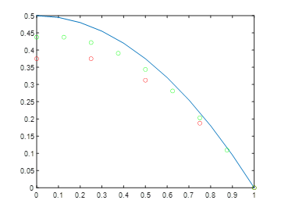

**1.2.14.** (a) Solve with free-fixed conditions and . The complete solution involves integrating twice, plus .

(b) With and ,,, compute the discrete ,, using : with and . Compare with the exact answer at the center point . Is the error proportional to or ?

**Sol.** (a)

(b) MATLAB codes:

>> x=[0:0.05:1]'; plot(x,1-x.^4,'r -'); hold on % the real solution

>> n=3; h=1/(n+1); x=[h:h:1-h]'; b=12*x.^2; K=toeplitz([2,-1,zeros(1,n-2)]); K(1,1)=1; u=K\(h*h*b); plot([0;x;1],[u(1);u;0],'b o')

>> n=7; h=1/(n+1); x=[h:h:1-h]'; b=12*x.^2; K=toeplitz([2,-1,zeros(1,n-2)]); K(1,1)=1; u=K\(h*h*b); plot([0;x;1],[u(1);u;0],'g o')

>> n=15; h=1/(n+1); x=[h:h:1-h]'; b=12*x.^2; K=toeplitz([2,-1,zeros(1,n-2)]); K(1,1)=1; u=K\(h*h*b); plot([0;x;1],[u(1);u;0],'y o')

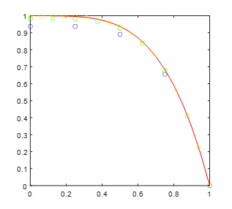

**1.2.15**. Plot the for and the discrete values at the mesh points . For small those values will not catch the oscillations of. How large is a good? How many mesh points per oscillation?

**Sol**. MATLAB codes:

>> x=[0:0.01:1]'; plot(x,cos(4*pi*x)); hold on; % the real solution

>> n=1; h=1/(n+1); x=[0:h:1]'; plot(x,cos(4*pi*x),'r o')

>> n=2; h=1/(n+1); x=[0:h:1]'; plot(x,cos(4*pi*x),'g o')

>> n=3; h=1/(n+1); x=[0:h:1]'; plot(x,cos(4*pi*x),'b o') % At least 3 middle points can reveal its oscllation.

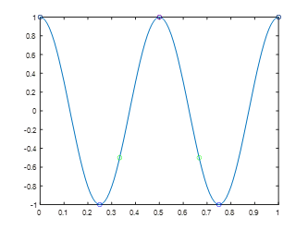

**1.2.16**. Solve with fixed-fixed conditions . Use and to compute ,, and plot on the same graph with : with .

**Sol.**

>> plot([0:0.01:1]',(cos(4*pi*[0:0.01:1]')-1)/(16*pi^2), 'r -'); hold on; % the real solution

>> n=4; h=1/(n+1); x=[h:h:1-h]'; K=toeplitz([2,-1,zeros(1,n-2)]); b=cos(4*pi*x); u=K\((h^2)*b); plot([0;x;1],[0;u;0],'b o');

>> n=8; h=1/(n+1); x=[h:h:1-h]'; K=toeplitz([2,-1,zeros(1,n-2)]); b=cos(4*pi*x); u=K\((h^2)*b); plot([0;x;1],[0;u;0],'g o');

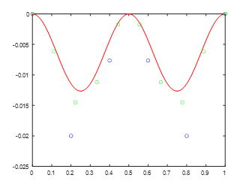

**1.2.17**. Test the differences and on . Factor out (this is why exponentials are so useful). Expand to find the leading error terms.

**Sol**.

with the leading error term of

with the leading error term of

**1.2.18**. Write a finite difference approximation (using ) with unknowns to with boundary conditions and . Solve for , , , . Compare them to the true solution.

**Sol**.

>> n=4; h=1/(n+1); x=[h:h:1-h]'; K=toeplitz([-2,1,zeros(1,n-2)]); u=K\(h*h*x); plot([0:0.05:1]',([0:0.05:1]'.^3-[0:0.05:1]')/6); hold on; plot([0;x;1],[0;u;0],'o');

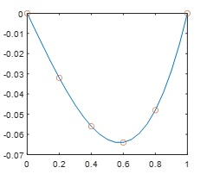

>> u-(x.^3-x)/6

ans =

1.0e-16 *

-0.1388

-0.3469

-0.2776

-0.2082

**1.2.19**. Construct a centered difference approximation using and to with and . Separately use a forward difference for . Notice . Solve for the centered and uncentered with . The true is the particular solution plus any . Which and satisfy the boundary conditions? How close are and to ?

**Sol**.

>> n=4; h=1/(n+1); K=toeplitz([2,-1,zeros(1,n-2)]); C=diag(-ones(3,1),-1)+diag(ones(3,1),1); b=ones(4,1); U=(K/(h^2)+C/(2*h))\b; D=toeplitz([-1,1,zeros(1,n-2)]); u=(K/(h^2)+D/h)\b;

>> x=[0:0.01:1]'; plot(x,x+(1-exp(x))/(exp(1)-1)); hold on; plot([0:h:1]',[0;U;0],'o'); plot([0:h:1]',[0;u;0],'s');

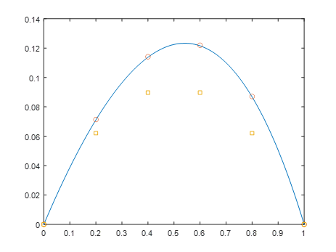

**1.2.20**. The transpose of the centered difference is (antisymmetric). That is like the minus sign in integration by parts when drops to zero at : .

Verify the summation by parts .

Hint: Change to in , and change to in ·

**Sol**.

**1.2.21**. Use the expansion with zero slope and to derive the top boundary equation . This factor removes the error from Figure 1.4: good.

**Sol**.